LAECA 2012 Conference
Louisiana Early Childhood Association
Keynote Speakers
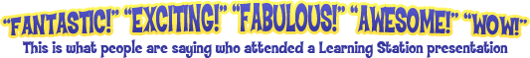
Join the Louisiana Early Childhood Association in Welcoming Back
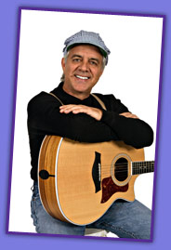
Don Monopoli of the Learning Station
LearningStationMusic.com
In the tradition of the finest motivational presentations, The Learning Station shares with participants their experience, passion and dedication to children's music. Their dynamic, interactive style and ability to connect with their audiences has achieved accolades throughout the world of education. Their enthusiasm is contagious, their energy is electrifying and their fun-loving humor will keep the entire audience involved, captivated and engaged.
The Learning Station has presented over 500 keynotes and workshops worldwide. They are recognized by such accredited organizations as the NAEYC, NCCA, Head Start, CCR&R Agencies and their affiliate organizations across the nation. They support "Healthy Music for a Child's Heart, Body & Mind!" with their presentations designed to inspire, inform and entertain. Everyone will be encouraged to participate and involve themselves first-hand, openly and creatively. Participation will be a blend of small group demonstration, entire audience and as individuals. There will be ample opportunities offered for everyone to share, reflect and respond. Attention will be given to the audience's special requests, interests and musical needs.

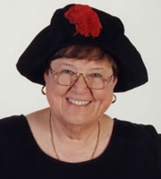
Mary Jo Huff
You will want to make plans to attend her Make & Take Session
Thursday, October 18, 2012
6:00 - 8:00 p.m.
Register Early Space is Limited

Mary Jo Huff is a multi-award winning author, recording artist, storyteller, and early childhood educator with 38 years of experience. Her CDs have won the NAPPA GOLD (National Parenting Publications Award), I parenting, Dove, Parent's Choice, and Teachers' Choice Awards. She has also won the Kid's First video, Creative Child Magazine CD of the year, and the Pegasus award from the National Storytelling Network.
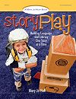
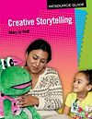
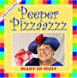
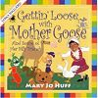
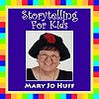
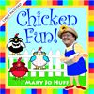

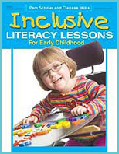

Featured Speaker

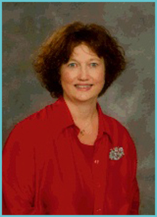
Clarissa Willis, PhD
Clarissa Willis has been involved in early childhood education for over 30 years. Her experience includes public school, early intervention, curriculum development, and teacher training. As an author, trainer, teacher special educator, grant administrator, and parent, Dr. Willis offers a unique perspective on issues related to early childhood development and early childhood special education. She is the author of six books and has been involved in writing special needs adaptations for twenty-five other publications. In addition, she has written special education lessons for three major curriculum companies.
Her publications include the award winning books, Teaching Young Children with Autism Spectrum Disorder, My Child has Autism, and Teaching Infants Toddlers and Twos with Special Needs (Gryphon House). She is co-author with Dr. Pam Schiller of Inclusive Literacy Lessons. In addition she also the author of Inclusive Environments for Young Children-What to do on Monday Morning! (Corwin Press). Her articles have also appeared in journals such as Young Children, Childcare Information Exchange, Dimensions of Early Childhood and Teaching Exceptional Children.

